
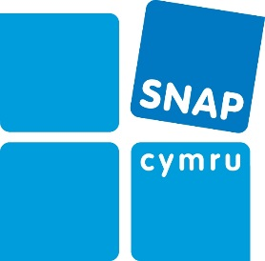

Referral in to SNAP Cymru
Early Help

From:
Organisation Name:
Organisation Contact:
Address:
E-mail:
Telephone: | Referral date:

Child / Young Person:
Name:
D.O.B: | Gender: | Ethnicity:
Child / Young Person’s Disability / Diagnosis:

Parent / Carer:
Name:
Address:
Post Code
Telephone: | Mobile:
E-mail:

School:
Name:
Language:
Contact name/email:

Details of referral:
Who is currently working with the family? What support are they providing?
What is going well? What are we worried about?
What needs to happen? Issues for SNAP Cymru

Are there any special requirements necessary to work effectively with this family? (E.g. accessibility / language)
Consent Statement

- I/parent agree to the use and sharing of information with SNAP Cymru

- I/parent understand(s) that there may be circumstances where SNAP Cymru will still share your/their information with other agencies without your/their agreement. This will include where it is necessary to do so to safeguard your child or yourself
- I/parent understand(s) that I/they can withdraw consent at any time

Parent / Carer / Young Person – | Professional: Consent from the parent to make this referral has been made?
Signed: | Signed:
Date: | Date:

Please send referral to: early.help@snapcymru.org
We will acknowledge receipt 0f the referral and contact the parent within 5 working days

