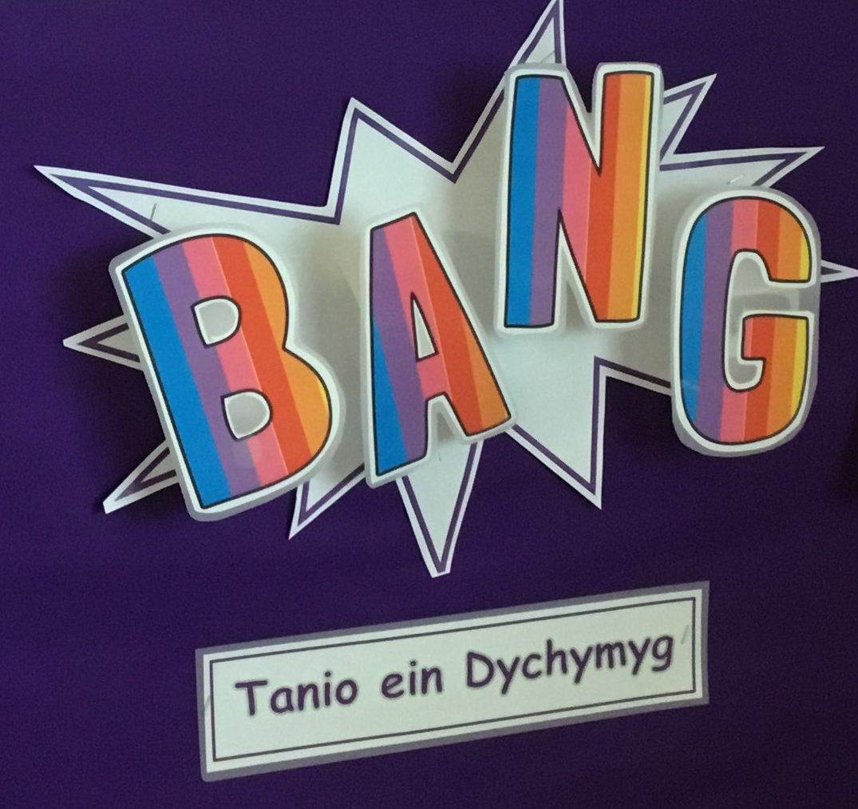
Let’s Plan!
I want to dress up.
Nova
Some clothes are old, and some are not.
Ffion Rae

We grow old when we celebrate our birthdays.
Ben
Choosing the Role-play Area
Surgery-18
House - 7

We need to take care of babies.
Alys
How do we grow?
Joe

Little babies can't walk.
Arleah
I like colours.
Harriet

We turn one, two, three, four and five.
Ioan

Remember to visit class pages on the school website for more information!
www.yggbrynymor.co.uk
Follow us on Twitter! @YGGBrynymor1


The Humanities
• Talk about likes/dislikes
• Recognise important events that have happened in the past e.g. birthdays, being a baby
• Sequence personal events and begin to understand the concept of the future e.g. think about what we would like to do when we grow up
•Start to understand things that are similar and things that are different between us
• Show awareness of how we change since being a baby e.g., recognize and explain what/how they have changed since being a baby.
• Learn about Christmas traditions and why Christmas is important to Christians
Health and Wellbeing
• Begin to express our feelings and develop strategies to control our emotions
• Learn about the importance of looking after our bodies e.g. personal hygiene, exercise
• Develop our fitness
• Practice and develop our hand-eye coordination, gross motor and fine motor skills
• Understand that everyone is different - notice differences between ourselves and our friends
• Visits from doctor/nurse, parent and baby, Designed to Smile (brushing teeth)

Languages, Literacy and Communication
• Playing games to develop concentration skills
• Create a 'Bryn-y-Môr Doctor’s Surgery' role play corner
• Listen to stories and poetry related to our big idea
• Learn vocabulary and songs about the body
• Tric and Chlic activities
• Express ourselves through mark making, drawing pictures and emergent writing
• Enjoy writing for a variety of purposes e.g. descriptive writing, invitations, cards, labelling.

The purpose of this learning unit is to give the learners an opportunity to learn about themselves and to consider 'What makes me, me?'. When starting to notice similarities and differences e.g., looks, preferences, we hope to foster an understanding that everyone is different and special, and to form positive relationships based on mutual respect.
We aim to develop learners who can communicate effectively about themselves, recognise and talk about changes in their past and come to understand sequences and patterns in everyday activities. We strive to develop
curious, inquiring learners, who naturally ask questions in order to find out more.
We intend to focus on practises that promote health, such as, personal care and hygiene, sleep and protection against infection and develop positive informed practises for life.
At the end of the learning unit, we trust that the learners will be able to connect and apply their knowledge and skills in order to solve the 'Bryn-y-Môr Nursery' problem.
Science and Technology
• Learn how our bodies change as we grow
• Use tools safely to build and deconstruct.
• Use digital devices to record their creations
• Use a variety of computing equipment safely
• Develop our coding skills by giving a series of instructions to a programmable toy e.g., Bee-bot
• Design, make and evaluate a Christmas decoration.

The Expressive Arts
• Enjoy singing familiar and new songs, focusing on traditional nursery rhymes.
• Performing in front of an audience e.g. Pori Drwy Stori
• Use simple body movements to create a dance, be aware of basic aspects such as speed, direction
• Identify and evaluate our own work, and the work of others
•Print with parts of the body.

Mathematics and Numeracy
• Develop our understanding of mathematical language through role-play and playing games
• Sing songs and reciting number rhymes
• Count, read, write and order numbers
• Develop our adding and subtraction skills
• Sort objects, collect and present data
• Investigate measures, shape, money and pattern
• Solve simple practical problems.

This terms big ideas:

Here are some of our ideas.
This is me!

