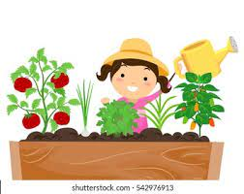
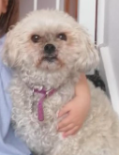
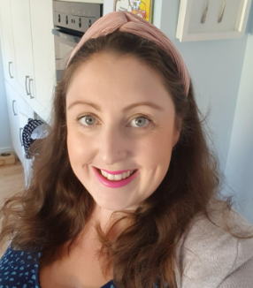
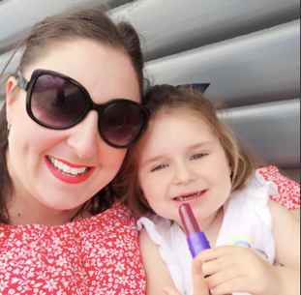
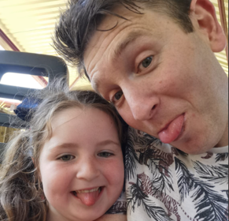
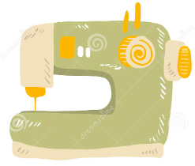
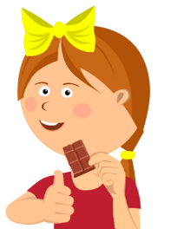
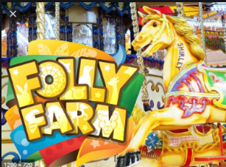
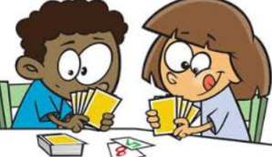
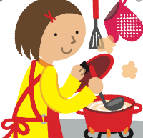


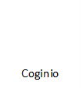

Fi, Mr Jones, Willow (5), Olwen (3) a Winnie y ci (the dog)
Gwnio
Sewing
Fy enw i yw: Mrs Kelly Jones
My name is

Amdanaf Fi
All About Me
Weithiau rwy’n teimlo’n ansicr mewn sefyllfaoedd newydd.
I sometimes feel uncertain and a little bit nervous in new situations.

Ymweld a Fferm Folly
Visiting Folly Farm

Chwarae gemau
Playing games

Garddio
Gardening

Bwyta siocled
Eating Chocolate

Coginio
Cooking
Pethau pwysig i wybod amdanaf fi
Important things to know about me
Dyma fy hoff bethau
Here are my favourite things
Dyma fi
This is me
Dyma fy nheulu
This is my family

