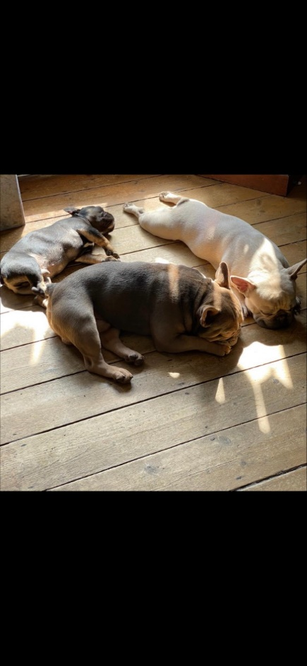
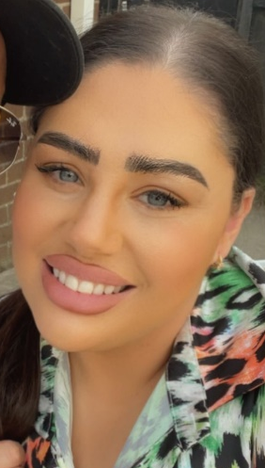


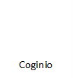
Rwy’n dwli ar fy nghwn Arthur, Mobi a Nico er ei bod nhw’n gallu bod yn ddrwg iawn!
I love my dogs Arthur, Mobi and Nico, although they can be very naughty!

Rwy’n joio mynd ar fy ngwyliau a treilio amser gyda fy ffrindiau a fy nheulu!
I enjoy going on holidays and spending time with my friends and family.

Rwy’n dwli ar gwylio Netflix a bwyta!
Watching Netflix and eating is something I love doing to relax!

Dyma fy merch Ysabela, fy mhartner a fy nhad!
This is my daughter Ysabela, my partner and my Dad.
Fy enw i yw: Miss Warwick
My name is

Pethau pwysig i wybod amdanaf fi
Important things to know about me
Dyma fy hoff bethau
Here are my favourite things
Amdanaf Fi
All About Me
Dyma fi
This is me
Dyma fy nheulu
This is my family



