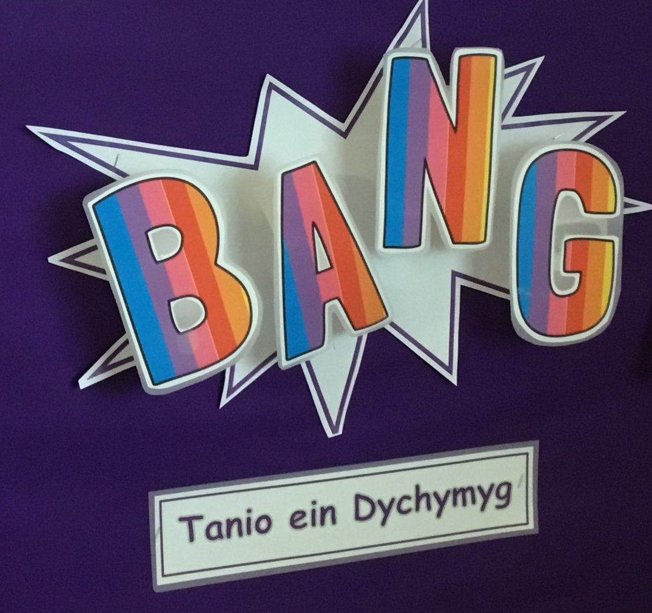
Lets plan!
Cows go in the stable
Cillian
How do the farmers make hay? Henry

The farmer cuts the sheeps wool. Eddy

I want to see the dogs tell the sheep what to do. Joe

The horse goes neeeeeigh!
Ebba

I want to play with horses and tractors. Maya

I want to go to a farm.
Myles

I want to sing ‘old Mac Donald’.
Gwenanz

I want to play in the mud! Pheonix

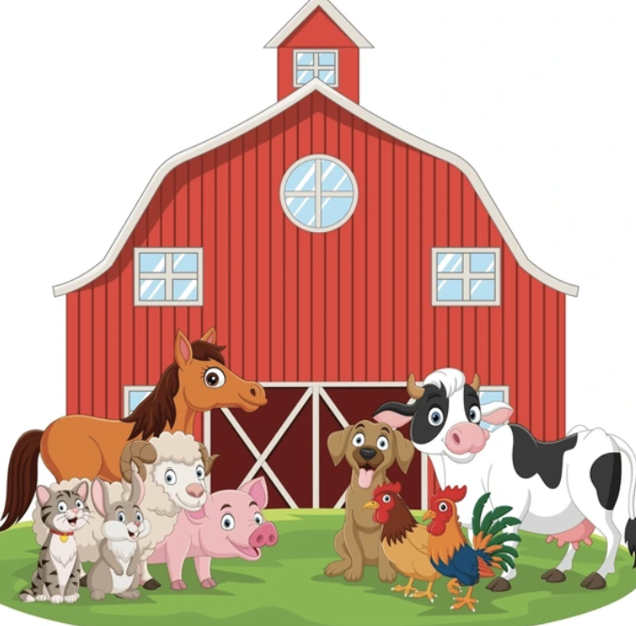
Our big idea this term is….
Moo, moo, mee, mee, quack, quack!
The purpose of this unit is to provide learners with opportunities to be curious about the world around them and to start learning about animals, produce and roles on the farm. Learners will enquire and develop a body of information about farm life through direct experiences. They will explore farm life and learn about the evolution of agriculture. Understanding and considering the effects of agriculture on how we produce food will contribute to developing ethical, informed citizens of the future. Learners will develop to be healthy confident individuals through planting seeds and growing vegetables. At the end of the unit learners will have the experience of connecting and applying their knowledge and skills to co-write a factual book.

The Expressive Arts
• Enjoy singing a range of songs, some that are new and familair ones.
- Chose a range of resouces whilst making a farm animal mask.
- Use creative resources carefully and safely.

Remember to look at the school website for pictures and more information -www.yggbrynymor.co.uk
Follow us on ‘X’! @YGGBrynymor1

Language, Literacy and Communication
- Play games to develop listening and concentrating skills.
- Explore and role play in the class ‘kitchen’
- Listen to a variety of stories and poems about the farm and animals
- Learn new vocabulary and songs related to the farm and animals
- Retell and re-enact simple stories using learnt vocabulary
- Pre reading and writing activities e.g. tuning into sounds, learning about rhyme and rhythm and practicing whole body movements
- Express ourselves using marks, drawing pictures and emergent writing
- Understand we can write in a range of styles e.g. lists and descriptions.

Humanities
• Be curious about my local area.
• Care for living things and the environment.

Visit to the community farm
28/2/24
Health and Wellbeing
- Show curiosity
- Express and make decisions
- Show care and respect towards others
- Practice and devlope my fine and gross motor skills and my hand eye co-ordination.

Science and Technology
- Observe farm animals and take notice
- Handle farm animals in the community farm
- Recognise that animals are living things
- Recognise and name a number of farm animals
- Discuss weays farmers care for and look after their animals
- Plant seeds and grow vegetables
- Observe the life cycle of chicks
- Use BEEBOT to plan a route around the farm
- Use digital recording equipment to record

Mathematics and Numeracy
• Develop understanding of mathematical language through role play and game playing
• Sing and recite number songs and rhymes e.g. 5 little ducks went swimming one day
• Count, read numbers and order numbers
• Classify and sort objects and collect data
• Research into shape, measure, money and patterns.
• Problem solve in practical ways

