Our intention in this unit of learning is to develop a sense of place and belonging. We aim to develop creative, curious and inquisitive learners who can think critically. We hope to nurture an understanding of the diversity within society to foster knowledgeable learners who can show empathy and respect towards others. By developing their creative skills, we aim to encourage ambitious learners who will feel pride in their work and value the achievements of others. By the end of this unit of learning we trust that our learners will be responsible and informed citizens, and feel a sense of pride and appreciation for their habitat – ‘cynefin’.
Here are our ideas for this term’s work!

Maeve- I’d like to go to a church.
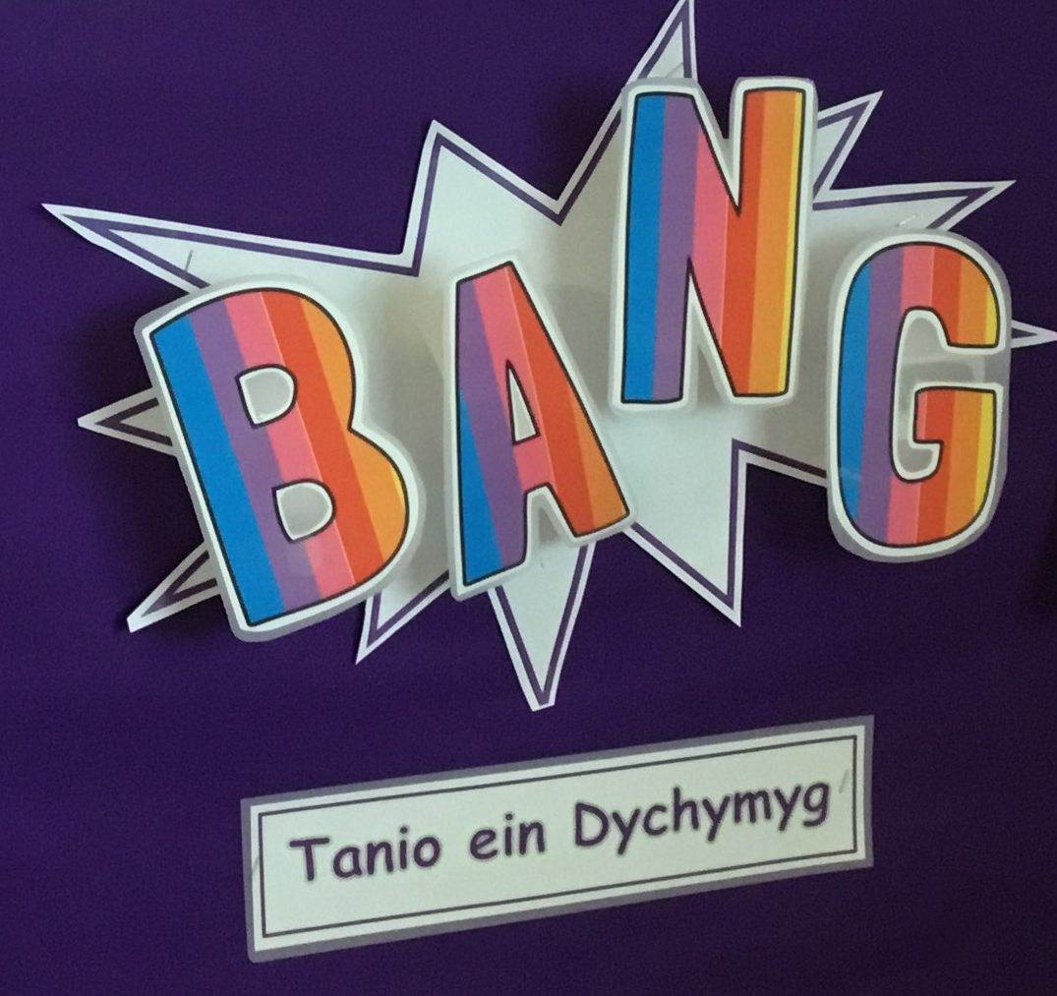

Betsi- I want to go to a cafe in town.
Leo- I like Joes ice cream. Can we taste some in school?
Olwen- I’d like to see inside the Brangwyn Hall
Mabli – How does Joes make nice ice cream?
Visits: Copper Jack boat trip, Brynmill Park, Glynn Vivian Gallery and local places of worship.
Closing project: Create an art gallery to display our printing work

‘Super Swansea!’
Here are some of our ideas for the term!
Mathematics and Numeracy
- Develop our understanding of mathematical language through role play and playing
- Practise counting, recognising, writing and arranging numbers.
- Practise and develop our addition, subtraction and multiplication skills.
- Use money, practise measuring skills and study shape and time.
- Enjoy playing a variety of mental mathematical games.
- Collect and present data.

Languages, Literacy and Communication
- Create a ‘role– play corner based on a Swansea business, such as a coffee shop, bakery or general store. (The pupils will vote to decide on their favourite.)
- Continue to practise our reading skills and enjoy listening to a variety of stories and poems.
- Enjoy writing for a variety of purposes, including factual writing, expressing an opinion, persuasive writing and letters.
- Continue to practise our spelling and handwriting skills.

Science and Technology
- Use various computer equipment safely.
- Develop our coding skills.
- Learn about the characteristics of materials.

A homework menu for the term will be shared with the children. Please see the instructions on the class page on the school website. https://www.yggbrynymor.co.uk/dosbarth-y-tonnau-mrs-k-jones/
Health and Wellbeing
- Continue to develop our fitness and improve our gymnastic skills.
- Practice and develop hand-eye coordination, fine and gross motor skills.
- Enjoy new experiences during Forest School (Year 1 only) sessions and various visits
- Discuss school rules and how to be responsible citizens.
- Understand our roles and responsibilities within the Swansea community.
- Discuss our feelings and how others should be treated.
Make decisions about our work, both as individuals and as a member of a group.

Humanities
- Learn about our habitat ‘cynefin’ and about the city of Swansea.
- Discuss our favourite things
- Learn about the history and development of Brynmill and Swansea parks.
- Discuss and study the most prominent natural and human features of the city of Swansea.
- Develop our mapping skills.
- Learn about Christmas traditions and why Christmas is important to Christians.
- Study and visit different places of worship, exploring the cultural diversity of the Swansea community.

Expressive Arts
- ·Study the work of local artist Sarah Hopkins.
- ·Enjoy developing our drawing and printing skills, emulating the work of a local artist's work.
- Create presentations and short films of all kinds, including advertisements promoting Swansea’s unique features.
- ·Enjoy singing a range of songs.

