
Dyma gerdyn gwaith cartref ar gyfer y tymor. Ewch i’r adran ‘Gwaith Cartref’ ar dudalen gwe’r dosbarth i gael mynediad at yr adnoddau.
Y Gragen Gwaith Cartref

Here’s a homework menu card for this term. Visit the ‘Homework’ section on the class web page to access the resources
Y Gragen Homework
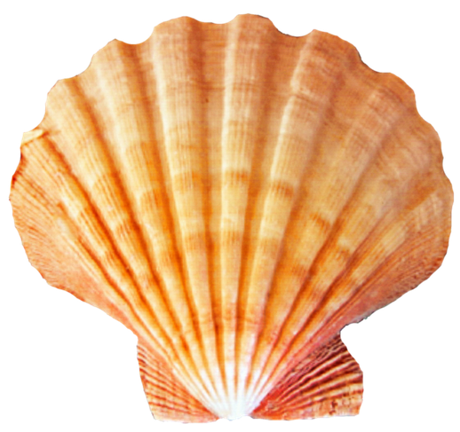

Tasg Ddigidol  Dysgwch i fewngofnodi i Hwb yn annibynnol. Mae eich enw defnyddiwr a’ch cyfrinair i’w gweld yn eich llyfr cyswllt cartref. Hwb (gov.wales)  Tasg ychwanegol:  Tynnwch lun gan ddefnyddoio rhaglen jit. Arbrofwch wrth newid maint y brwsh, lliwiau, a stampiau.  Digital Task  Learn to log in to Hwb independently. Your username and password can be found in your home-school contact book. Hwb (gov.wales)  Extra task:  Draw a picture using jit. Experiment by changing the size of the brush, the colour and adding stamps. | Tasg Rhifedd  Ewch ati i ymarfer ffurfio pob rhif yn gywir.  Dewiswch un o’r posteri ffeithiau rhif sydd yn y blygell ar wefan y dosbarth ac ewch ati i geisio dysgu a chofio’r ffeithiau.  Numeracy Task  Learn to form all numbers correctly.  Choose one of the number facts posters from the file on the class web page and try to learn and remember the number facts. | Tasg Sillafu  Dewiswch ychydig o eiriau aml-eu defnydd o’r rhestr ar y wefan. Beth am ddechrau gyda 3 gair. Ewch ati i ymarfer a dysgu eu sillafu. Sawl un fedrwch chi sillafu tybed?  Tasg ychwanegol:  Dewiswch fideo Tric a Chlic i’w wylio. Beth am ymuno yn y wers a cheisio darllen a sillafu’r geiriau hefyd?  Spelling Task  Choose a few words from the high-frequency word list on the website. Why not begin with three words? Practise spelling these words. How many words can you spell correctly?  Extra Task:  Choose a Tric a Chlic video to watch. What about joining in the lesson and try to read and spell the words? | Tasg Llawysgrifen  Ewch ati i ymarfer ffurfio pob llythyren yn yn eich enw yn gywir. Edrychwch ar y daflen ar y wefan a fydd yn eich helpu i ffurfio’n gywir.  Handwriting Task  Learn to form all letters in your name correctly. Take a look at the handwriting sheet on the website which will guide you. | Tasg Ddarllen  Cofiwch ddarllen eich llyfr darllen adref. Gallwch hefyd ddarllen eich llyfrau llyfrgell a chael myediad at rhagor o lyfrau ar wefan Darllen Co. Defnyddiwch eich enw defnyddiwr a chyfrinair Hwb i fewngofnodi.  Reading Task  Remember to read your reading book at home. You may also read your library books and also access more books via the digital reading platform Darllen Co.  Log-in using your Hwb username and password.

Dosbarth y Gragen

