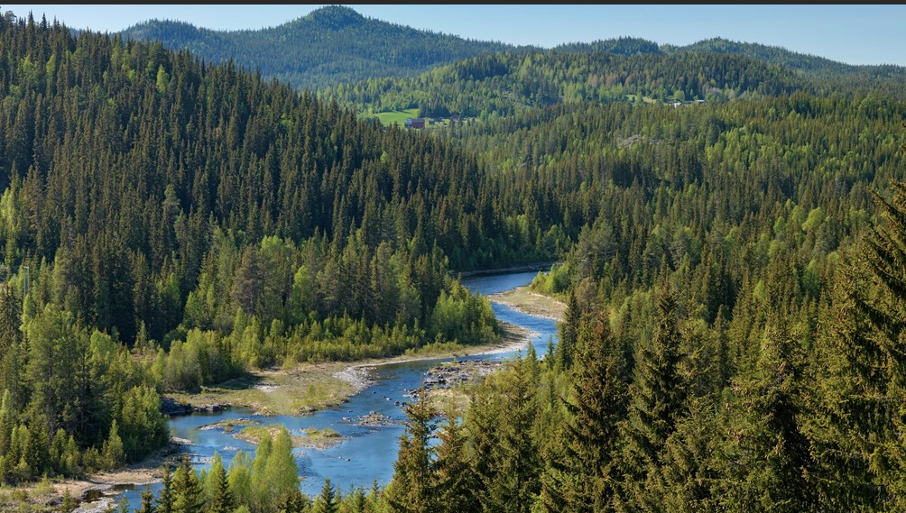
Visits/Visitors/Workshop
A day in Bishopston woods learning survival skills.
A day orienteering.
A class visit from Lowri Morgan, endurance athlete and tv personality who succeeded in completing the Arctic Challenge.

Addysg Gorfforol
Science and technology
Science
Living Things
We will be looking at global warming through the eyes of the Arctic, one of the places that’s seen the most change.
How is the Arctic changing?
What lives in the Arctic?
We will be looking at the evolution of animals.
We will be looking at things that we can do to lessen the effect of global warming.
Healthy eating: an investigation into healthy foods.
We will be discussing the difference between fact and opinion.
Digital Competency
We will be concentrating on internet safety this term.
Coding projects using the microbit.
Coding instructions for the sphero.
Design and Technology
Design and create a board game.
Textiles – designing and creating a door stop.
Work for the Urdd competition.
Language, Literacy and Communiacation
Speaking
Explain a point of view, present information, convey feelings, instruct and recount.
Discuss, consider and evaluate their own work and the work of others.
Reading
The class novel will be Shadow Forest by Matt Haig
First News.
The internet for research.
Writing
Planning and research work will be presented as mind maps.
We will be using Shadow Forest as a basis for writing in a variety of forms this term, including a diary, newspaper article, review and a portrait of a character.
We wil be using the Urdd’s writing competition as a prompt to write a poem and sililoque.

Writing

Theme: Opening Doors
Year: 5 and 6

Cwricwlwm Cymreig
Cymharu’r Aifft a Chymru
Astudio’r Mosg yng Nghaerdydd
Gwrando ar gerddoriaeth Cymreig
Ymweliad / Digwyddiad
Y Ganolfan Eifftaidd, Abertawe

Mathematics and Numeracy
Time – 12 hour and 24 hour clock.
Angles
Number sequence and the nth term.
Adding and subtracting positive and negative numbers.
Problem solving
Ratio
Adding and subtracting fractions.
Practising reasoning questions
Numeracy
Orienteering activities in the open air.
Multiplying numbers and decimals.
Cwricwlwm Cymreig
Cymharu’r Aifft a Chymru
Astudio’r Mosg yng Nghaerdydd
Gwrando ar gerddoriaeth Cymreig
Ymweliad / Digwyddiad
Y Ganolfan Eifftaidd, Abertawe
Humanities
History
We will be investigating the early life of the Vikings and links to Swansea.
Geography
We will be studying Norway and characteristics of the country (glaciers, fjords, the Auriora Borealis). We will be ldiscussing climate change and the melting glaciers.
Religous Education
We will be discussing the importance of having traditions.
We will be learning about Buddihsm.

Expressive Arts
Art
Art projects for the Urdd competition. The theme this year is Summit to Sea.
Animation work for class projects.
We will be looking at the work of Edvard Munch.
Cerddoriaeth
We will be learning new songs in preparation for the Ysgol Gyfun Gwyr transition concert.
Drama
Film. Role playing using the Green Screen.

Health and Welfare
Food Technology
We will be investigating healthy snacks for adventurers.
Personal and Social Education
We will be discussing the importance of having a balance between screen time and other aspects of life.
We will be discussing the importance of standing together on Holocaust Memorial Day and discussing the lives of refugees today.
The focus for internet safety day this year is displaying our identity on line for others to see.
We will be learning survival skills in the forest.
Physical Education
Gymnastics until half term.
Hockey, badminton and rugby after half term.
Year 5 will be having swimming lessons.

