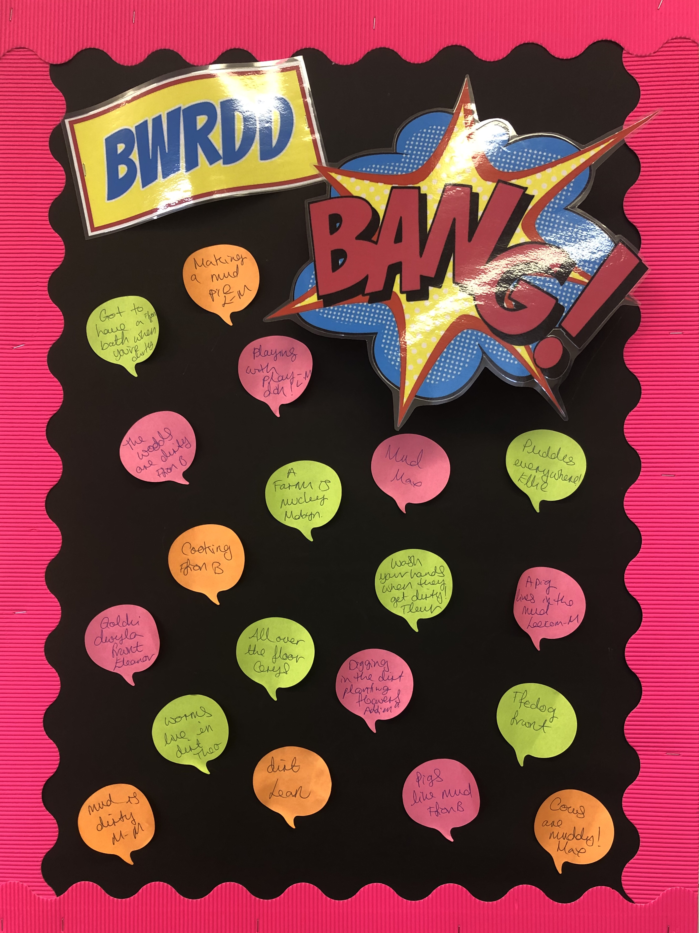
Let’s Plan!
Choosing Role Play Activities
Gardening - 8
Cooking - 29
I like muddy puddles!
Ellie

I want to do some cooking!
Ffion B

We wash when we are dirty.
Eleanor

Worms live in mucky mud!
Theo

Cows are muddy.
Maxwell

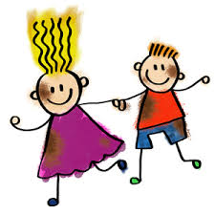
Expressive Arts

• Explore and experiment with different materials
• Learn songs about St David’s Day
and Easter. • Learn how to express ourselves
creatively

Language, Literacy and Communication
• Listen to and enjoy lots of different stories and
poems related to the theme
• Learn songs, rhymes and nursery rhymes
• Express ourselves through mark making, drawing
pictures and emergent writing

Mathematics and Numeracy

• Developing our understanding of mathematical
language through role-play and playing games
• Singing songs and reciting number rhymes
• Counting, ordering, comparing and sorting objects
• Recognise and write numbers
• Explore money, measures, shape and pattern
Health and Well-being

• Playing games to develop our concentration skills
• Showing care, respect and affection for other children, adults and the environment
• Learn about dangerous mixtures
• Becoming more independent and confident in our learning
• Practise and develop our gross motor and fine motor skills and hand-eye co-ordination

Humanities

• Learn about various celebrations e.g. Pancake Day, Saint
David’s Day, Easter
• Read the story The Little Red Hen

Visits/Visitors
Visit to Swansea Farm – Date TBC

The theme is:
Muck, Mess & Mixtures
Here are our ideas for this term.

Science and Technology
• Learn about the properties of different materials
• Learn about the sensory properties of a variety
of materials
• Learn about similarities and differences between
materials and changes in them
• Listen to and follow a simple series of
instructions and create verbal instructions

Don’t forget to visit www.yggbrynymor.co.uk -pupils section – class pages’ on our school website for more information.
Follow us on ‘twitter’ also! @YGGBrynymor1

