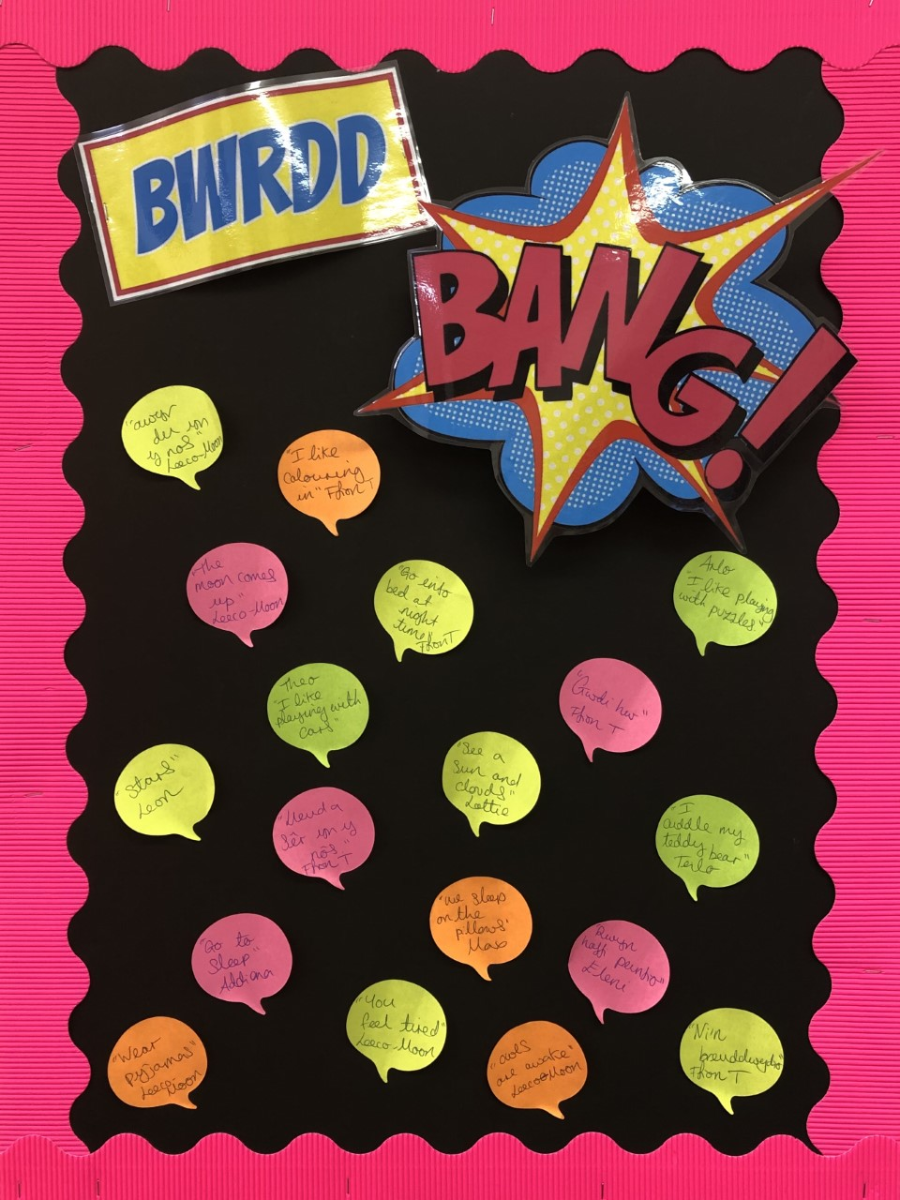
Let’s Plan!
Why do we see stars at night time?
Leon

Mabon
I like painting, can we paint the sky?
Eleni

I want to show everyone my teddy bear.
Teilo

I would like to learn about the moon and stars.
Ffion Tomos

Why do we see the sun and clouds in the day time?
Lottie

I want to listen to stories about going to bed.
Ffion Bevan
I know owls are awake at night time. Are any other animals awake too?
Leeco-Moon

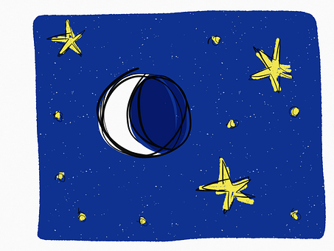

Language, Literacy and Communication
• Create a ‘Mr and Mrs Bear’s House’ role-play area from the story Peace at
Last
• Listen to and enjoy lots of different stories and poems related to
the theme
• Learn songs, rhymes and nursery rhymes
• Express ourselves through mark making, drawing pictures and
emergent writing

Visits/Visitors
Visit to see Father Christmas – Clyne Farm 06/12/19
Christmas Assembly - Pantygwydr Church 13/12/19

Health and Well-being
• Playing games to develop our concentration skills
• Showing care, respect and affection for other children, adults and the
environment
• Learn about being and feeling safe at night
• Becoming more independent and confident in our learning
• Practise and develop our gross motor and fine motor skills and hand-eye
co-ordination
Science and Technology
• Learn about the moon and the stars and the night sky • Learn about nocturnal animals
• Learn about sources of light and that dark is the absence of light

Expressive Arts
• Draw pictures of nocturnal animals
• Imitate ‘Starry Night’ by Van Gogh
• Learn lullabies and songs about the
night
• Respond creatively to Bonfire Night
• Perform our Christmas Assembly
Digital Competency Skills:

• Learn how to add our name to a piece of work
• Learn how to save our
work and retrieve it
Don’t forget to visit www.yggbrynymor.co.uk -pupils section – class pages’ on our school website for more information.
Follow us on ‘twitter’ also! @YGGBrynymor1

This term’s theme is:
When I fall Asleep
Here are our ideas for the term.
Humanities
• Learn about bedtime routines
• Learn about the traditions of Christmas
• Learn about changes in nature

Mathematics and Numeracy
• Developing our understanding of mathematical language through role-
play and playing games
• Singing songs and reciting number rhymes
• Counting, ordering, comparing and sorting objects
• Start to recognise and write numbers
• Explore measures, shape and pattern

