Let’s Plan!
What happens to water on a cold day?
Hudson

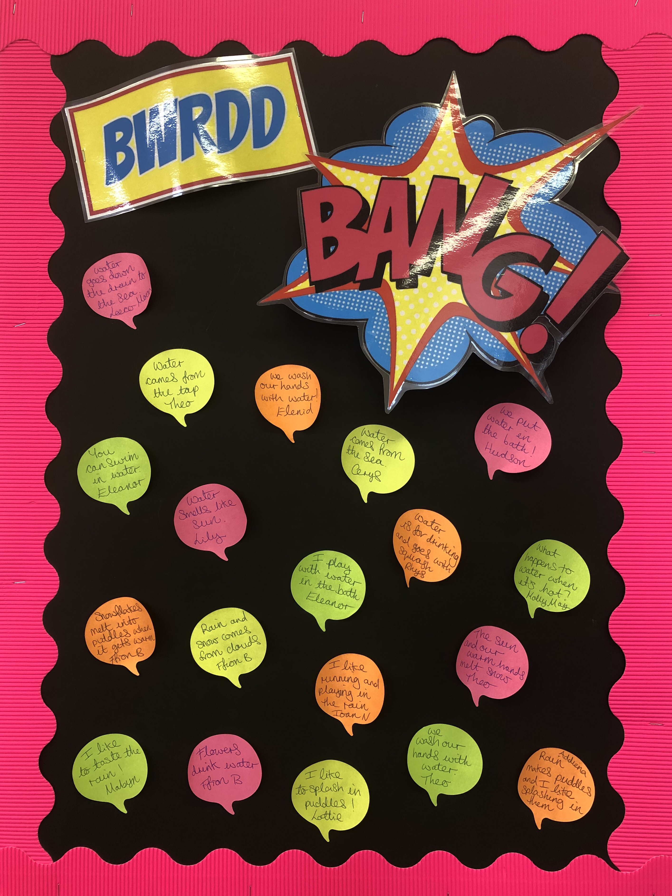
What happens to the puddles on a fine day?
Molly-May

What happens to water on a cold day?
Leeco-Moon

Which animals live in water?
Addiena

Ducks can float. What else floats?
Mabyn

I want to sing songs about the weather.
Elenid

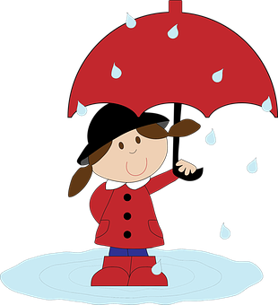
Expressive Arts
• Explore and experiment with colour and water
• Learn songs about the weather
• Learn how to respond to sounds and music using our bodies imaginatevly
• Study and emulate Monet’s ‘Bridge over a pond of lilies”

Language, Literacy and Communication
• Listen to and enjoy lots of different stories and poems related to the theme
• Learn songs, rhymes and nursery rhymes
• Express ourselves through mark making, drawing pictures and emergent writing

Humanities
• Identify natural water features e.g. streams, rivers, ponds, the sea
• Learn about various celebrations e.g. St Dwynwen’s Day
• Read the story of Noah’s Ark

Health and Well-being
• Playing games to develop our concentration skills
• Showing care, respect and affection for other children, adults and the environment
• Learn about being safe near water
• Becoming more independent and confident in our learning
• Practise and develop our gross motor and fine motor skills and hand-eye co-ordination

Science and Technology
• Learn about water in its various forms
• Learn about how water is used at home
• Learn about all sorts of weather
• Learn about animals that live in ponds and rivers
• Learn about floating and sinking
• Learn about choosing suitable clothing to wear

The theme is:
Pitter Patter in the Puddles
Here are our ideas for this term.

Don’t forget to visit www.yggbrynymor.co.uk -pupils section – class pages’ on our school website for more information.
Follow us on ‘twitter’ also! @YGGBrynymor1

Mathematics and Numeracy
• Developing our understanding of mathematical
language through role-play and playing games
• Singing songs and reciting number rhymes
• Counting, ordering, comparing and sorting objects
• Recognise and write numbers
• Explore money, measures, shape and pattern

Visits/Visitors
TBC

