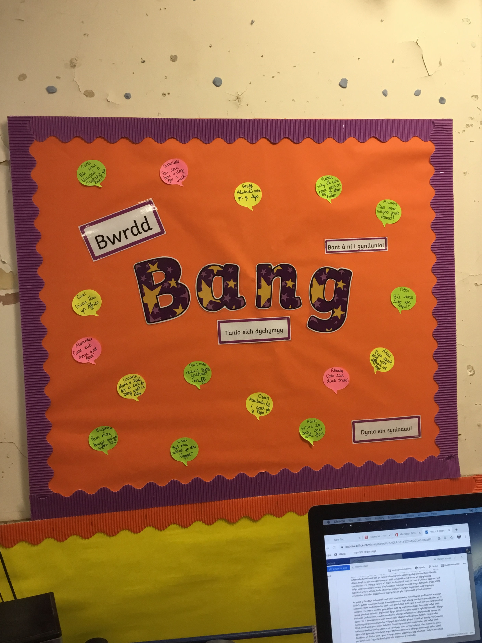
Let’s Plan!
Why can owls see in the dark?
Phoebe
I’d like to wear pyjamas!
Alexander

Why do the stars sparkle?
Gabrielle

You have to brush your teeth!
Sam

Why do we take little teddies to bed with us?
Darcey

I want to read some bedtime stories!
Etta

Why do owls sleep at night?
Megan

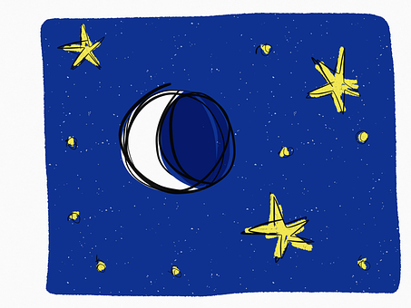

Language, Literacy and Communication
• Create a ‘Mr and Mrs Bear’s House’ role-play area from the story Peace at
Last
• Listen to and enjoy lots of different stories and poems related to
the theme
• Learn songs, rhymes and nursery rhymes
• Express ourselves through mark making, drawing pictures and
emergent writing

Visits/Visitors
Llygoden yr Eira Show
28/11/19
Christmas Assembly- Pantygwydr Church 13/12/19

Health and Well-being
• Playing games to develop our concentration skills
• Showing care, respect and affection for other children, adults and the
environment
• Learn about being and feeling safe at night
• Becoming more independent and confident in our learning
• Practise and develop our gross motor and fine motor skills and hand-eye
co-ordination
Science and Technology
• Learn about the moon and the stars and the night sky • Learn about nocturnal animals
• Learn about sources of light and that dark is the absence of light

Expressive Arts
• Draw pictures of nocturnal animals
• Imitate ‘Starry Night’ by Van Gogh
• Learn lullabies and songs about the
night
• Respond creatively to Bonfire Night
• Perform our Christmas Assembly
Digital Competency Skills:

• Learn how to add our name to a piece of work
• Learn how to save our
work and retrieve it
Don’t forget to visit www.yggbrynymor.co.uk -pupils section – class pages’ on our school website for more information.
Follow us on ‘twitter’ also! @YGGBrynymor1

This term’s theme is:
When I fall Asleep
Here are our ideas for the term.
Humanities
• Learn about changes in nature as we explore Brynmill Park
• Learn about bedtime routines
• Learn about the traditions of Christmas

Mathematics and Numeracy
• Developing our understanding of mathematical language through role-
play and playing games
• Singing songs and reciting number rhymes
• Counting, ordering, comparing and sorting objects
• Start to recognise and write numbers
• Explore measures, shape and pattern

