Ysgol Gymraeg Bryn y Môr
Blynyddoedd Derbyn a Meithrin
Gwrandewch ar stori ‘Waldo a’i We Wych’. Fedrwch chi dynnu lluniau’r siapiau wrth wrando?  Listen to the story ‘Waldo a’i We Wych’. Can you draw the shapes as you listen to the story?    https://soundcloud.com/pori-drwy-stori/listen-to-waldo-ai-we-wych | Gwyliwch y fideo ‘Helfa Siapiau’. Ewch ar helfa siapiau fel Mrs Jones.  Derbyn- Fedrwch chi gofnodi eich canfyddiadau?  Watch the ‘Shape Hunt’ video. Go on a shape hunt like Mrs Jones.  Reception- Can you record your findings?   | Ferdwch chi ddod o hyd i we go iawn? Edrychwch yn ofalus arni ac yna ewch ati i greu gwe wych eich hunan!  Can you find a real spider’s web? Look at it really carefully and then have a go at making your own web!  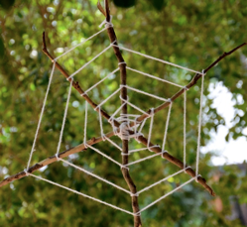  
Amser Siarad!  Roedd Waldo’n benderfynol o greu gwe berffaith. Ceisiodd a cheisiodd nes iddo lwyddo. Ydych chi wedi dal ati i ddysgu gwneud rhywbeth newydd? E.e. reidio beic, gwisgo eich hunan. Dywedwch wrth aelod o’r teulu/danfonwch fideo at eich athrawes.  Talk Time!    Waldo was determined to make a perfect web. He tried and tried until he succeeded. Have you persevered to learn how to do something new? E.g. ride a bike, dress yourself. Tell a family member about it/send a video to your teacher. | Dewch o hyd i wybodaeth am bry cop. Beth am greu llyfr ffeithiol?  Find out information about spiders. Have a go at making a factual book. | 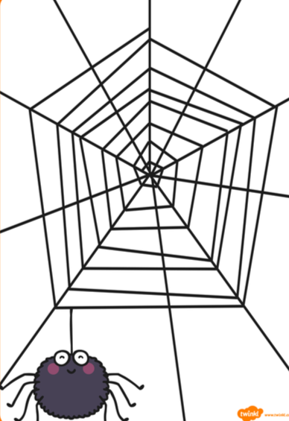  Beth am ganu ‘Dringodd y Pry Copyn’ gyda Mrs Hiley?  Sing ‘Dringodd y Pry Copyn’ with Mrs Hiley.

Dyma’r cerdyn BINGO am yr wythnos hon. Sawl her gallwch chi eu cwblhau, tybed?
Here is the BINGO card of challenges for the week. How many can you complete?

