Let’s Plan!
Choosing our Role-play Area
Launderette-14
House - 5
What happens to the puddles on a fine day?
Mabon

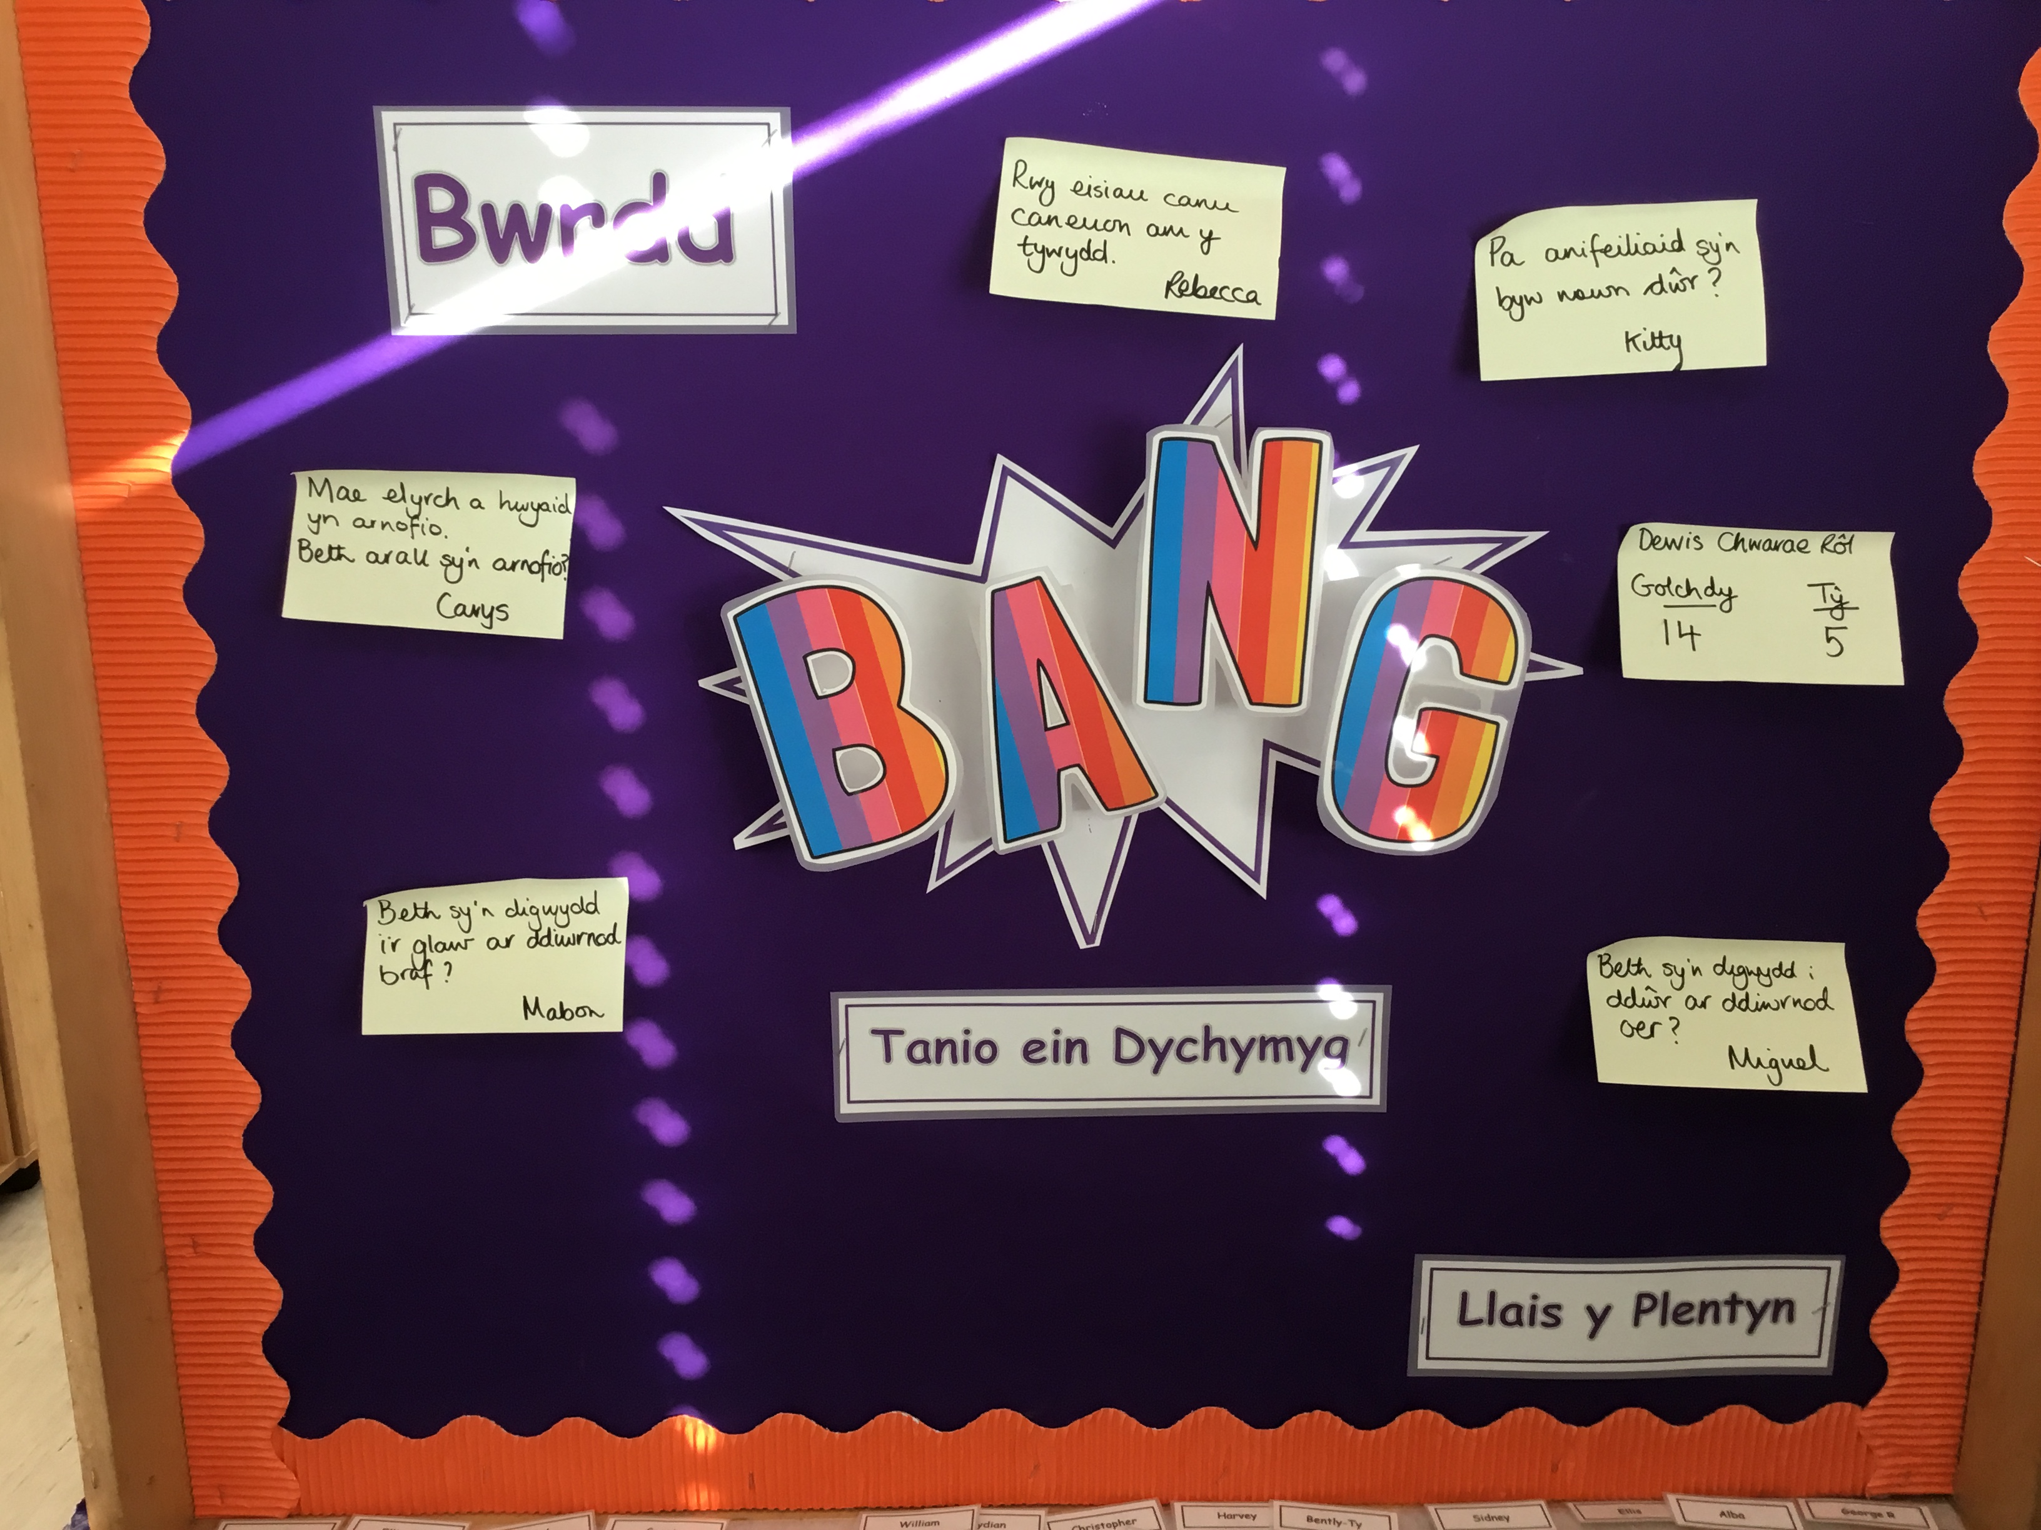

What happens to water on a cold day?
Miguel

Which animals live in water?
Kitty

I want to sing songs about the weather.
Rebecca

Ducks and Swans can float. What else floats?
Carys


Language, Literacy and Communication
• Create ‘Mrs Wishi-Washi’s Launderette’ role-play
area
• Listen to and enjoy lots of different stories and
poems related to the theme
• Learn songs, rhymes and nursery rhymes
• Express ourselves through mark making, drawing pictures and emergent writing

Health and Well-being
• Playing games to develop our concentration skills
• Showing care, respect and affection for other children, adults and the environment
• Learn about being safe near water
• Becoming more independent and confident in our learning
• Practise and develop our gross motor and fine motor skills and hand-eye co-ordination

Science and Technology
• Learn about water in its various forms
• Learn about how water is used at home
• Learn about wet weather including storms
• Learn about animals that live in ponds
• Develop our picture making skills on J2Launch
• Begin to learn about Online Safety

The theme is:
Pitter Patter in the Puddles
Here are our ideas for this term.

Don’t forget to visit www.yggbrynymor.co.uk -pupils section – class pages’ on our school website for more information.
Follow us on ‘twitter’ also! @YGGBrynymor1

Expressive Arts
• Explore and experiment with colour
and water
• Learn songs about the weather
• Learn how to respond to sounds
and music using our bodies
imaginatevly

Mathematics and Numeracy
• Developing our understanding of mathematical
language through role-play and playing games
• Singing songs and reciting number rhymes
• Counting, ordering, comparing and sorting objects
• Recognise and write numbers
• Explore money, measures, shape and pattern

Humanities
• Learn about changes in nature as we explore Brynmill Park
• Learn about washing clothes in olden days
• Identify natural water features e.g. streams, rivers, ponds, the sea
• Learn about various celebrations e.g. St Dwynwen’s Day

Visits/Visitors
Brynmill Launerette 13/1/20
Llanelli Wetland Centre 3/2/20

