Ysgol Gymraeg Bryn y Môr
Blynyddoedd Derbyn a Meithrin
Gwrandewch ar Mrs Hiley yn darllen ‘Ffred yn Dweud Cwac!’    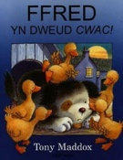  Listen to Mrs Hiley reading ‘Ffred yn Dweud Cwac!’ | Beth am chwarae gêm  ‘Ble mae’r…?’ gydag anifeiliaid y fferm?    Play ‘Where’s the….?’ with some farm animals. | Derbyn- Fedrwch chi ysgrifennu brawddeg ar JiT am anifeiliaid y fferm? Cofiwch i arbed eich gwaith. Mae ‘na fanc o eiriau i’ch helpu.    Reception- Can you write a sentence about the farm animals on JiT? Click on the shared file and remember to save your work. There’s a word bank to help you. | Fedrwch chi greu synau’r anifeiliaid sydd yn y stori?  Derbyn-cwblhewch y daflen ‘Cyfateb Sŵn ac Anifail’.  Can you make all of the animal sounds that are in the story?  Reception- complete the ‘Match the Animal and Sound’ worksheet.    https://soundcloud.com/bookstart-dechrau-da/honc-honc-me-me-honk-honk-baa-baa
Siaradwch am y stori. Mae ‘na daflen cwestiynau ar y wefan.  Talk about the book. There’s a questions sheet on the website.     | Mae Ffarmwr Bob eisiau i chi wneud ysgytlaeth gyda llaeth y fuwch. Beth fyddech chi’n dewis i roi yn eich ysgytlaeth?  Farmer Bob would like you to make milkshake with the cow’s milk. What will you choose to put in your milkshake?  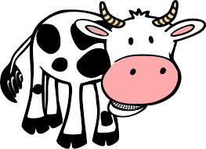 | Mae Ffarmwr Bob yn mynd i werthu potel fawr o’ch ysgytlaeth yn y farchnad. Dewch o hyd i’r botel sy’n dal y mwyaf.  Farmer Bob is going to sell a big bottle of your milkshake in the market. Find the bottle that holds the most. (You may want to do your investigating with water!)  https://nrich.maths.org/12491 | Beth am ganu ‘Pum Hwyaden’ gyda Mrs Jones?  Sing ‘Pum Hwyaden’ with Mrs Jones.  

Dyma’r cerdyn BINGO am yr wythnos hon. Sawl her gallwch chi eu cwblhau, tybed? Here is the BINGO card of challenges for the week. How many can you complete?

