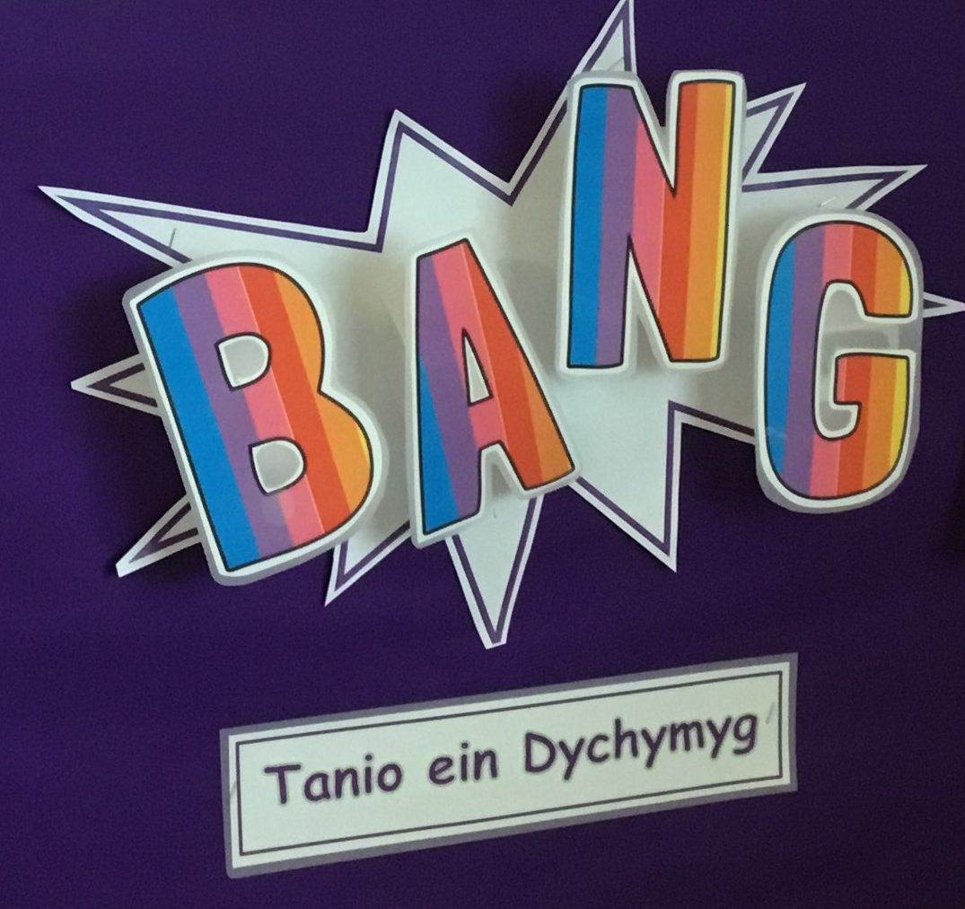
Let’s Plan!
Spiders make spiderwebs to catch flies.
Lucas

Snails have got homes that they carry on their backs that are shells.
Celyn

Bees make honey.
Rosie

We can build a bug hotel.
Lukas

Some bugs can fly and some don’t.
Dafydd

The worms wriggle.
George

How long are worm’s bodies?
Charlie

Slugs are slimy.
Betsi

I want to grow flowers.
Eloise

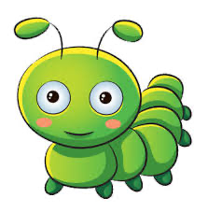
Visits & Experiences!

- Plantastia visit in school
- Visit Brynmill/ Singleton Park

Mathematics and Numeracy
• Develop an understanding of mathematical vocabulary through role play and games.
• Sing songs and recite number rhymes.
• Count, read, write and order numbers.
• Distribute objects and collect data.
• Investigate measures, shapes and patterns.
• Solve problems practically.

Language, Literacy and Communication
- Play games to develop concentration skills
- Explore and role play in the class ‘kitchen’
- Listen to stories and poetry about the big idea
- Learn vocabulary and songs about the big idea
- Retell and re-enact simple stories using learnt vocabulary
- Pre reading and writing activities, e.g., listening games
- Express themselves through mark making, drawing pictures and early writing
- Enjoy writing using different genres, e.g., fact file

Remember to visit class pages on the school website for more information!

www.yggbrynymor.co.uk

Humanities
- Be curious about the local area
- Care for living things and the environment

The World of Minibeasts
This term’s big idea:

Here are some of our ideas.
The aim of this unit of work is to give pupils the opportunity to be curious about the world around them and start learning about sustainability of the planet. Pupils will be given the opportunity to inquire and to develop a knowledge of minibeasts through direct experiences. They will investigate their habitats and learn what’s needed to survive. Understanding and considering how their actions can affect minibeasts and their habitats will contribute to developing pupils to be ethical, informed citizens of the future. At the end of the unit children will be given the opportunity to connect and apply their knowledge and skills to create ‘a minibeast world’. They will need to communicate effectively while presenting information about their favourite minibeast and explain how they made their models.

The Expressive Arts

- Explore and experiment with clay using a variety of tools and techniques
- Plan and create a minibeast out of clay
- Create a minibeast exhibition for parents to view it
- Enjoy singing new and familiar songs

Health and wellbeing

- Show curiosity
- Express and make decisions
- Show care and respects to others
- Practice and develop fine motor skills and hand-eye co-ordination
- Prepare, practice and take part in sports day

Science and Technology
- Go on a minibeast hunt
- Observe minibeast in their habitats
- Recognise that animals are living things that grow
- Recognise and name a number of minibeasts
- Start to name body parts of minibeasts and their characteristics
- Discuss ways of caring for minibeasts
- Observe the life cycle of a butterfly
- Categorise and sort mini beasts
- Use digital equipment to record their creations
- Explore a variety of computer hardware
- Give instructions to a robotic toy, such as Code-a-pillar or Bee-bot.

