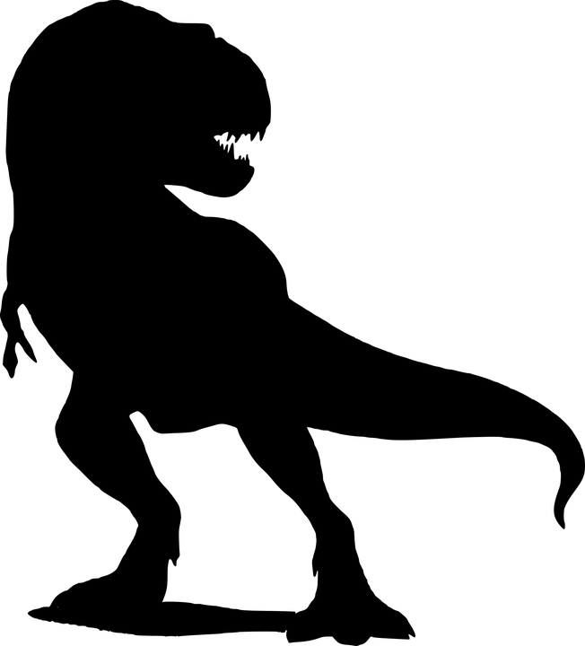
Creative Development
• Make our own ‘fossils’
• Learn songs and rhymes about
dinosaurs
• Express ourselves creatively
through moving our bodies to
‘dinosaur’ music

Physical Development
• Develop our gross and fine motor skills, and hand eye coordination by moving like dinosaurs, making models and fossils

Religious Education:
• Learn about people who
help us

Digital Competency Skills:

• Develop our programming skills
• Develop our understanding of
online communication

Mathematical Development
• Developing our understanding of mathematical language through role-play
and playing games
• Singing songs and reciting number rhymes
• Counting, ordering, comparing and sorting objects
• simple  in practical situations 
• Recognise and write numbers
• Explore measures, shape and pattern

Personal and Social Development,Well-being and Cultural Diversity
• Playing games to develop our concentration skills
• Express likes and personal interests and talk about our favourite dinosaur or model
• Becoming more independent and confident in our learning
• Working as a group to make a model of a dinosaur
Knowledge and Understanding of the World
• Learn about different types of dinosaurs and their body parts
• Learn the word ‘extinct’ and what it means
• ☹earn about herbivores and carnivores

About bedtime routines; About the moon and stars and how the sky changes at
night; About sources of light and that dark is the the absence
of light; About nocturnal animals; About time; How to sing simple lullabies and nursery rhymes; How to express their own ideas and feelings about
dreams; About being safe and feeling safe at night;
How to record their ideas and experiences through mark marking, drawing and writing.

- Animal care, including organisations and charities that provide animal welfare

• Dysgu am gynefinoedd lle mae cathod yn byw yn y cartref ac yn y gwyllt
• Dysgu am rannau cyrff cathod

Don’t forget to visit www.yggbrynymor.co.uk -pupils section – class pages on our school website for more information.

Follow us on ‘twitter’ also! @YGGBYMKJones

Visits/Visitors
A visit from a ‘real’ T. Rex 24/4/18

This term’s theme is:
Battle of the Dinosaurs
Here are our ideas for the term.
Language, Literacy and Communication Skills
•  □  enjoy lots of different stories and poems related to
the theme
• Learn songs, rhymes and nursery rhymes
• Ff a Fflac a Sam Cap Coch
• Express ourselves through mark making, drawing pictures and
emergent writing

