Clwb Gofal Bryn y Môr

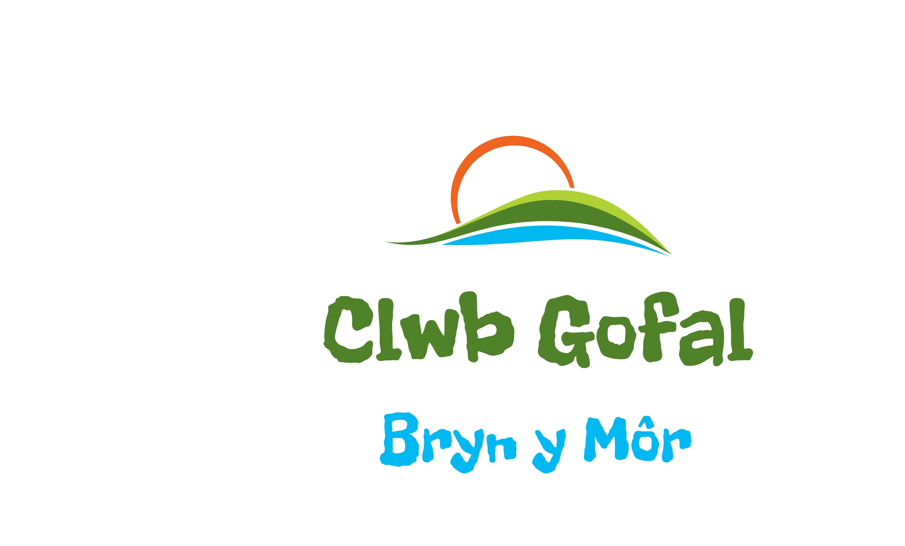

Behaviour Policy

The United Nations Convention on the Rights of the Child (CRC) is at the heart of Clwb Gofal Bryn y Môr’s policies, procedures, practice and ethos. We not only teach about children’s rights but also model rights and respect in all relationships

Behaviour Policy

Children attending Clwb Gofal Bryn y Môr have the right to play and enjoy their activities without feeling intimidated, harassed, or be subject to verbal or physical abuse. We believe children have the right to feel safe and secure in our care, and we promote behaviour which encourages individuals to respect one another in the following ways:

• Children will be encouraged to follow Ysgol Gymraeg Bryn y Môr’s school rules and will be reminded of the behaviours that are acceptable / unacceptable. These rules will be shared and included as part of the induction policy.
• Good behaviour will always be praised by staff.
• The parent/carer and child will be informed of the acceptable limits, and the consequences of failing to comply with them.

• Children will be encouraged to talk through their feelings rather than resort to unacceptable behaviour.
• Discussing openly with children any issues so that they can develop their understanding of acceptable and unacceptable behaviour.
• Unacceptable behaviour will be dealt with as positively as possible with reasons being explained to the child involved.
• We will not tolerate bullying, harassment or intimidation and parents/carers will be informed if bullying persists. (see anti-bullying policy)
• Staff will not use any form of physical intervention unless it is necessary to prevent personal injury to a child, other children, an adult or serious damage to property.
• Behaviour that is likely to lead to the health and safety of others being compromised is also not acceptable.
• Staff will act as positive role models at all times.

In Instances of unacceptable behaviour, the following steps will apply:

• The incident will be discussed privately with the child, in an appropriate way and taking full account of the child’s level of understanding and he/she will be encouraged to resolve any conflict with other child/ren involved.
• We will gauge appropriate behaviour by the individual child’s age, level of understanding and specific needs. Children who have recognised behavioural difficulties will be given extra support in the Club to help them manage their own behaviour. We recognise that there may be special circumstances which may affect a child’s behaviour, and we will deal with this appropriately.
• Details of a more serious incident are recorded in our incident book and the parent/carer informed, and any action taken, on the day it occurred.
• Should the unacceptable behaviour continue, the child will be excluded. This will firstly be discussed with the management team and the parent/carer. Conditions may be put in place to enable the child to return to the Club.
• The child will be kept informed as to what will happen at each stage of this process as relevant and appropriate to age and understanding.

If a child commits a serious act, the management team reserves the right to exclude that child immediately and their parent/carer will be contacted. Parents/carers have the right to appeal using the clubs complaints policy and procedures.

This Policy will be kept under review and any revisions will be notified to Parents/Carers and CSSIW within 28 days as appropriate.

Policy Adoption
Policy Written on: 14/4/15
Reviewed: Annually, or sooner if required
Registered Person’s Signature:
Reviewed:- 13/09/16
Reviewed on 14/9/16
10/02/17, 05/10/18, 10/10/19 – 9/6/23

