Clwb Gofal Bryn y Môr

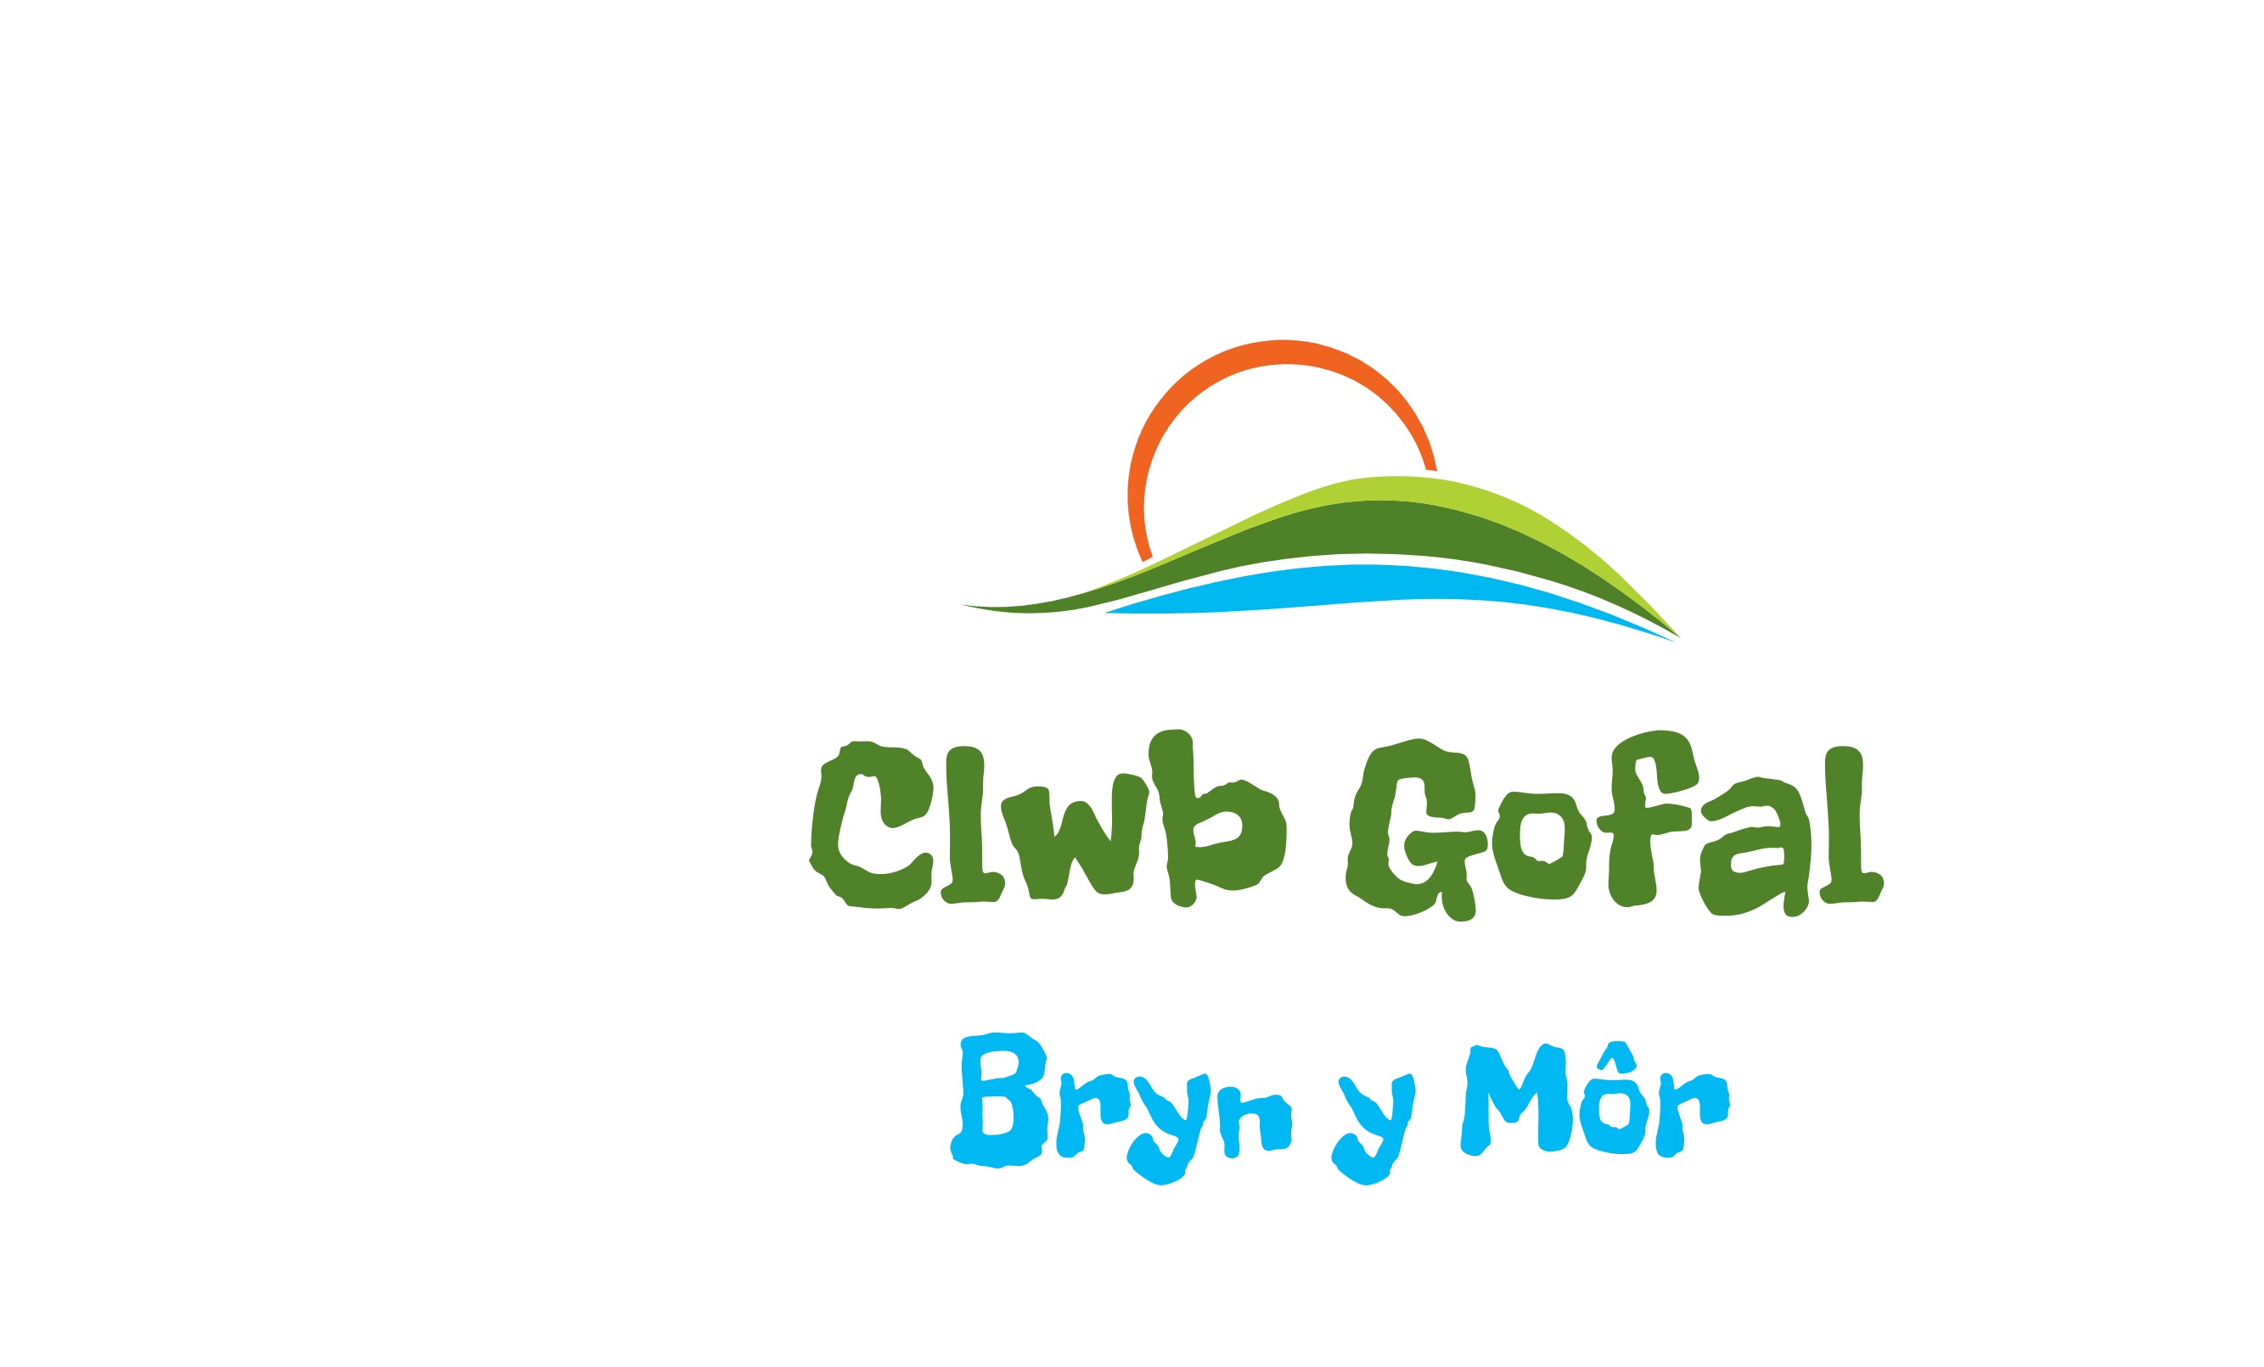

ALN Policy

The United Nations Convention on the Rights of the Child (CRC) is at the heart of Clwb Gofal Bryn y Môr’s policies, procedures, practice and ethos. We not only teach about children’s rights but also model rights and respect in all relationships

ALN Policy

Children who need extra support in school may not need extra support within the after school club setting. However some children may require specific treatment, facilities or care while in the Club that is above and beyond the usual provision for most children.
Clwb Gofal Bryn y Môr aims to provide a welcoming and supportive environment for all children, staff and parents/carers. They will be treated with dignity and respect. The Club supports integration and the treatment of all children and adults as individuals, wherever this is possible. Please refer to our Equal Opportunities policy.

• Club staff will consult with children and parents/carers as appropriate with regard to children’s individual needs and preferences, and if appropriate, liaise with the school’s ALNCo for advice and guidance in order to ensure that the individual in question has his / her needs catered for. This will be done in a sensitive manner and follow the school’s guidelines on making a written request for support.
• The individual needs and views of children are considered when planning activities and buying toys/games and other equipment.
• The Club aims to provide adaptations to the facilities and environment in order to cater for individual additional needs where this is practicable and reasonable.
• Where appropriate, children’s progress will be monitored and recorded in consultation with parents/carers. Strategies will be discussed with the child and parents/carers, and where appropriate, shared with the ALNCo before being implemented.
• Staff will receive training as required. Where appropriate, the school’s ALNCo will inform / train staff members as to how to maximise the learning / skill development opportunities for certain individuals.
• Full co-operation will be given to outside agencies in order to meet the specific needs of a child. This will be done in conjunction with the ALNCo where appropriate.
• If a child needs one to one support at the Club, we will make every effort to work with the parents/carers, ALNCo and relevant organisations to access additional funding and extra staff members to provide one to one support.
• The level of individual care is agreed with parents/carers. The Club will ensure that the privacy and dignity of a child is respected and maintained when providing any intimate care. This will be done through the use of the school’s staff toilet which has appropriate facilities to meet these needs.
• The Club promotes anti-discriminatory practices and encourages a positive atmosphere for all children.

Policy Adoption
Policy Written on: 14/4/15
Reviewed: Annually, or sooner if required
Registered Person’s Signature:
Reviewed:- 16/09/16.
Reviewed on 14/9/16
07/09/17, 05/09/18, 07/10/19 / 9/6/23

