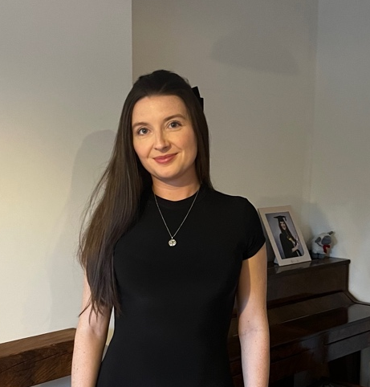
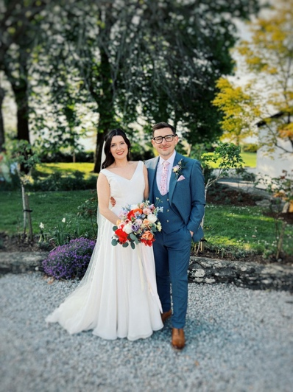
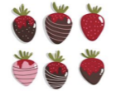
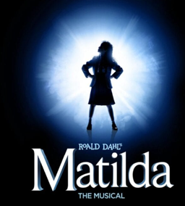
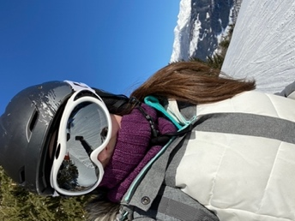
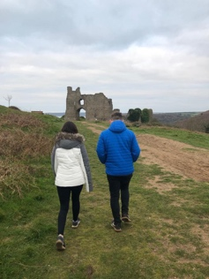


Efallai bod rhai ohonoch chi eisoes yn fy adnabod fel Miss James ond rydw i wedi priodi'n ddiweddar ym mis Ebrill!
Some of you may already know me as Miss James but I have recently married in April this year!
Pethau pwysig i wybod amdanaf fi
Important things to know about me
Dyma fy ngŵr, James.

Here’s my husband, James.
siocled a mefus

chocolate and strawberries
sgio
skiing
sioeau cerdd
musicals
y lliw pinc
the colour pink
cerdded
walking
Dyma fy nheulu
This is my family
Dyma fi
This is me
Dyma fy hoff bethau
Here are my favourite things
Fy enw i yw Mrs Smart
My name is Mrs Smart

Amdanaf Fi
All About Me

