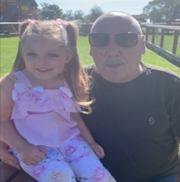
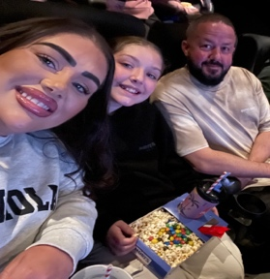
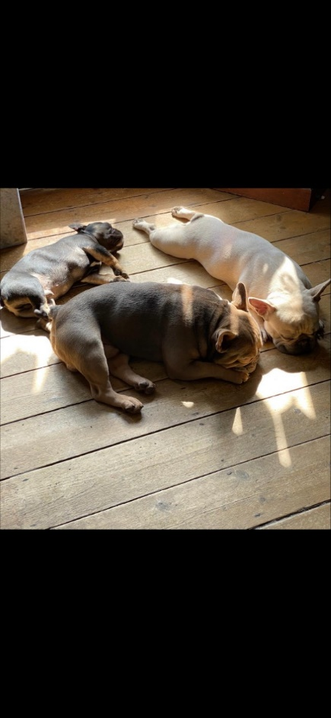


Rwy wedi bod yn gweithio yn y dosbarth meithrin am sbel nawr ac yn dwlu ar chwarae, cael hwyl a mwynhau profiadau newydd. Rwy’n edrych ymlaen i gwrdd a phawb!
I’ve worked in nursery class for a little while now and I love playing, having fun and enjoying new experiences. I can’t wait to meet you all x

Dyma fy nheulu
This is my family
Rwy’n dwlu ar fy nghwn er ei bod nhw’n gallu bod yn ddrwg iawn!
I love my dogs, although they can be very naughty!
Rwy’n joio mynd ar fy ngwyliau a threilio amser gyda fy ffrindiau a fy nheulu!
I enjoy going on holidays and spending time with my friends and family.
Rwy’n dwlu ar ddyddiau allan a bwyta bwyd neis.
I love to go on days out and eating good food.
Fy hoff liw yw gwyrdd ond rwy’n dwlu gwisgo du!
My favourite colour is green but I love wearing black!

Dyma fy merch Ysabela, fy mhartner a fy nhad!
This is my daughter Ysabela, my partner and my Dad.

Pethau pwysig i wybod amdanaf fi
Important things to know about me
Dyma fy hoff bethau
Here are my favourite things
Fy enw i yw: Miss Warwick
My name is Miss Warwick

Amdanaf Fi
All About Me
Dyma fi
This is me


