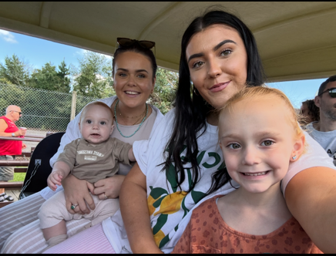
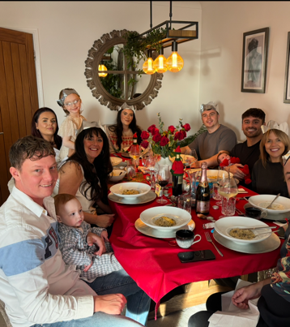
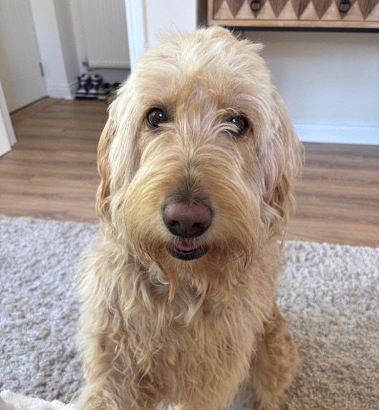
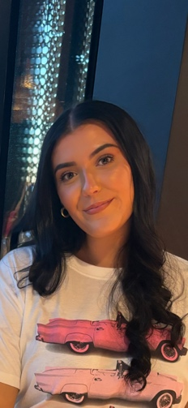


Dyma llun o fi, fy mhartner, a fy nheulu.
Here’s a picture of me, my partner and my family.
Dyma yw fy ail flwyddyn yn y meithrin ac rwy’n edrych ymlaen at gwrdd â phawb!
This is my second year in nursery, and I can’t wait to meet everyone!
Rwy’n dwlu mynd ar wyliau a fy hoff le yw Paris.
I love going on holidays and my favourite place is Paris.
Mae gen i gi o’r enw Lily ac mae hi’n wyllt!
I have a dog named Lily and she is crazy!
Fy hoff liw yw melyn.
My favourite colour is yellow.
Rwy’n hoffi treulio amser gyda fy ffrindiau a fy nheulu.
I enjoy spending time with my family and friends.
Fy hoff bethau i wneud yw siopa a mynd mas am fwyd a falle ymweld â sba rhywle!
My favourite things to do are shopping, going for food, and maybe visiting a cheeky spa somewhere!
Dyma fy nheulu
This is my family
Dyma fi
This is me
Pethau pwysig i wybod amdanaf fi
Important things to know about me
Dyma fy hoff bethau
Here are my favourite things
Fy enw i yw Miss Morgan
My name is Miss Morgan

Amdanaf Fi
All About Me

