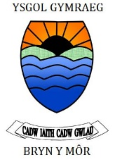
What is the Parent Forum for Ysgol Bryn y Mor?
The Parent Forum is a group of parents selected to represent the views all parents. Parent Forum have an important role to play in school improvement by ensuring that the parental perspective is represented and taken into account.

What is the role of the Parent Forum?
The Parent Forum helps to create an environment where all parents know that their views matter, and where they feel confident and comfortable putting them forward. They work on behalf of all parents to discuss educational matters that are of importance to all. They do not get involved in individual matters relating to children or staff in the school.

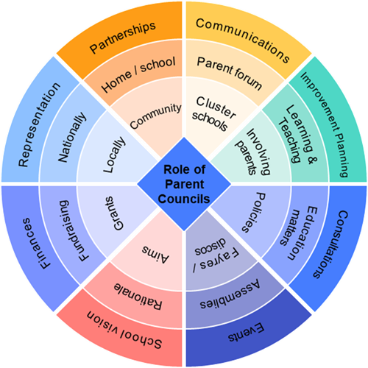
Role of Parent Forum

The Aims of the Parent Forum will be to:
- work together to improve the education provided for our children
- share information, knowledge and skills
- meet in a mutually supportive environment
- further improve communications between parent/carers and staff/governors
What will our Parent Forum do?
• Providing a two way route through which parents as a group can share and review views and information – ie to and from school – and support parents understand school processes and sysytems.
• Reaching out to parents and bringing parents together.
• Enabling parents to get involved in the life of the school, including supporting learning activities inside and outside of school hours.
Terms of Reference/Core Purpose the Parent Forum will be to:
• Give notice of meetings and an agenda to Parent Forum members and the Headteacher at least 5 working days in advance of a meeting.
• Minute all meetings and make them available to all parents/carers
• Be involved in identifying priorities for the school
• Advise the school on parental views
• Complement the Governing body (not be a replacement for them)
• Not be the forum for complaints about individual teachers, pupils, parents or individual issues, (these should be raised with the class teacher and/or Head teacher)
• Be positive, constructive and solution focussed
To follow Ysgol Bryn y Mor’s ‘Code of conduct’
• Have an open invitation to the meetings for the Chair of Governors
• Invite other members of staff to the meetings either as an observer or to contribute something specifically requested
• Meet at least termly
• Help ensure communication between parents and the school is the best it can be
• Review the impact of its work annually
• Review terms of reference annually
‘Golden Rules’ to observe during meetings:
• Respect confidentiality and never name individual teachers, pupils, members of staff or other parents.
• Support and be guided by the Chair of the meeting
• Keep to time and the agreed agenda
• Attempt to keep individual contributions brief
• Respect others’ opinions and ideas by letting them finish without interruption
I agree with the terms of reference above.
Signed…………………………………………….. Date…………………………..

How can a parent forum work for parents?
A parent forum that work for parents.
- Parents know who to contact on the Parent forum and in the school if they want to share views or have a query.
- Parents and school work together to support the health and wellbeing of children.
- The school and teachers keep parents informed of what their children will be learning so that they can discuss this with their children at home.
- Parents and staff tackle areas of difficulty and concern together.
- Parents support their children’s learning by helping with learning at home activities, homework and making links with other areas of school work.
- Parents and children know that everyone's contribution is valued.
- The ways of communicating with parents reflect the diversity of parents and their needs.
- There are open channels of communication so that parents feel comfortable talking to all staff (including Local Authority and external agencies).
- Parents are made aware of how their children’s learning can be supported at home. (eg freely available Welsh language lessons for adults, online virtual learning etc)

Communicating with the parent forum
Communicating with the parent forum is a key aspect of the role. As a Parent Forum you will want to tell parents about what you are discussing and what you intend to do. There are lots of ways in which the schools already communicate effectively with parents. However, parents might have ideas on how to improve these further. Consultation (e.g. a questionnaire, survey or some focus groups with different parents) about the preferred methods of communication, which will work best for the parent forum, is good practice.
Methods of communication may include:
- In person – using setting or school events, or creating an event(s) to meet the parent forum and gather their views;
- Written communication – newsletters, posters, noticeboards, flyers, letters, questionnaires;
- Technology – email, website, social media platforms, apps, text messaging, online meetings.
- Parent Forums should think about how best to contact parents of children who are about to join the setting or school, or how best to communicate with parents who require translation or alternative communication methods. Consideration should also be given to methods of communicating with parents who live apart but share the care and responsibilities for their child(ren).

